SPECIFICATIONS

IP CAMERA MODULE
2MP
H.265 / H.264

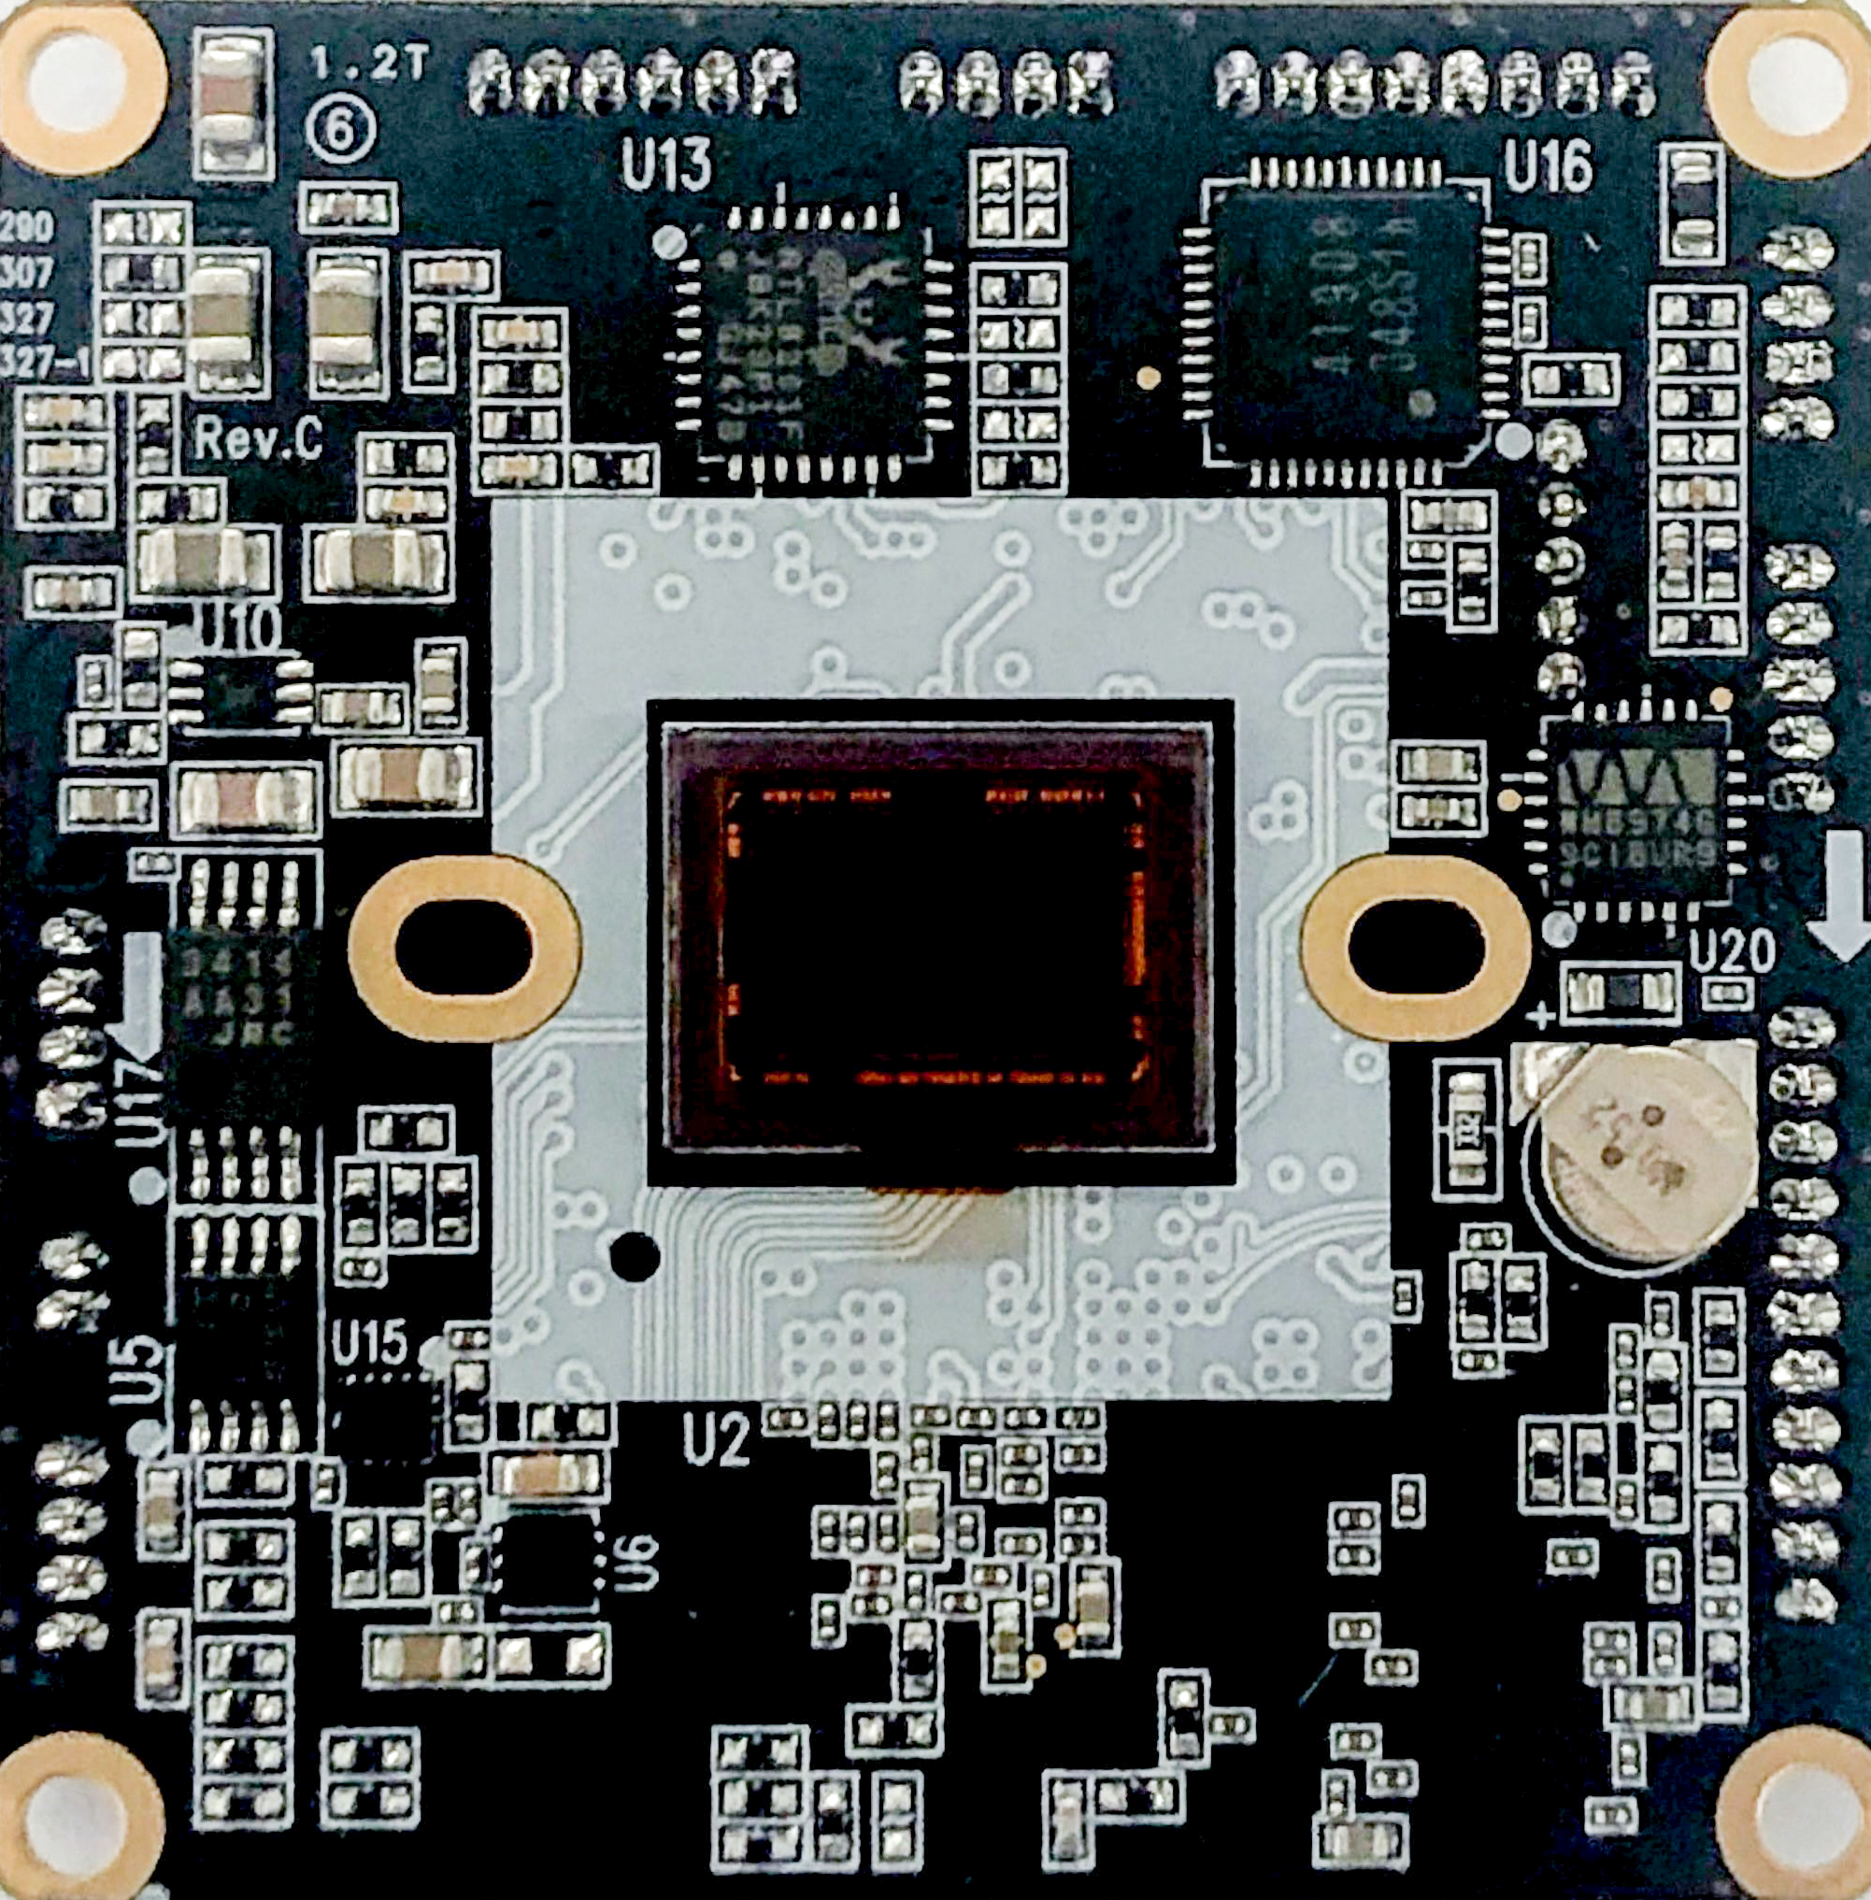

1. Block Diagram
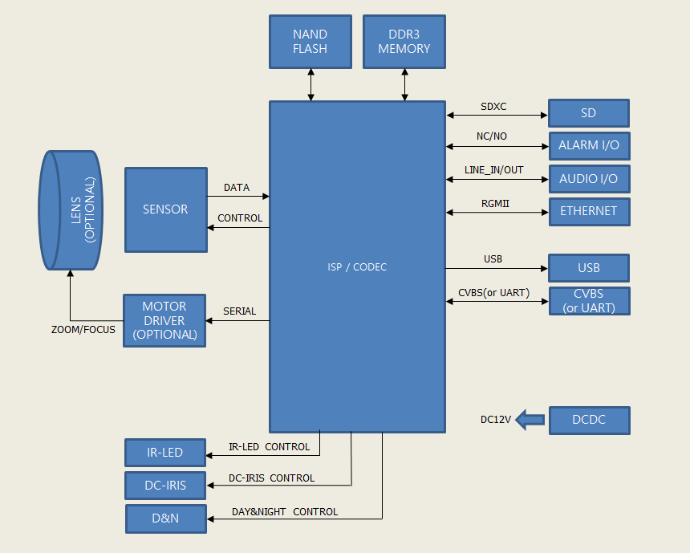

2. Module Dimension
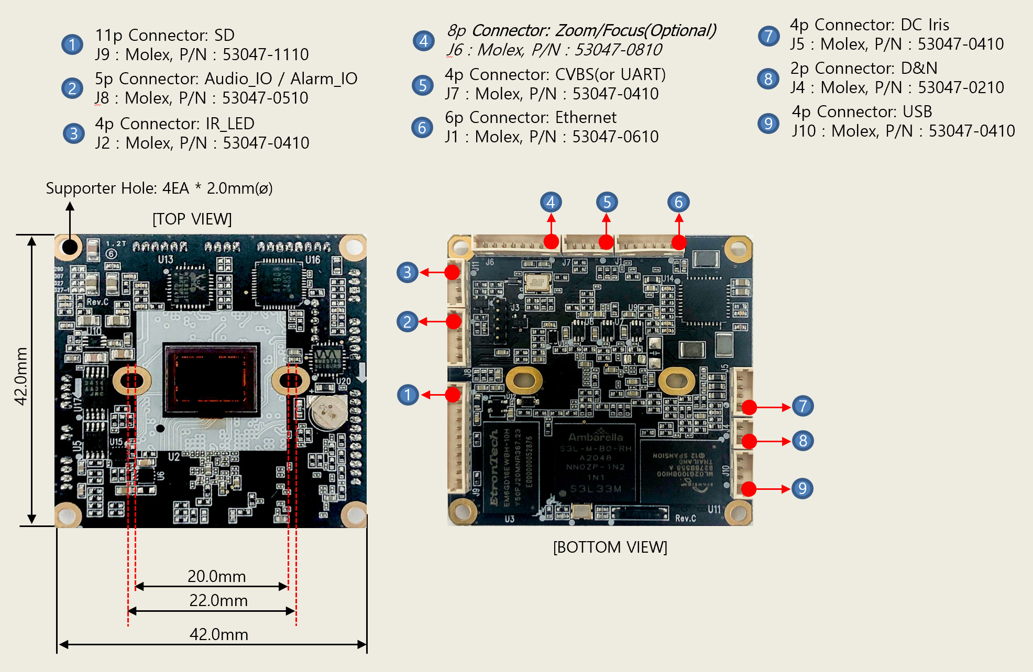
3. Connectors
J4 : DAY & NIGHT, Molex P/N : 53047-0210
Pin No. | Pin Name | Description
1 | Motor - | Night Mode : Active Low
2 | Motor + | Day Mode : Active High

J5 : DC IRIS, Molex P/N : 53047-0410
Pin No. | Pin Name | Description
1 | Drive - | Normally connect to GND
2 | Drive + | Iris motor drive
3 | Control + | Iris motor control +
4 | Control - | Iris motor control -

J2 : IR_LED, Molex P/N : 53047-0310
Pin No. | Pin Name | Description
1 | DC +12V | DC +12V Power output
2 | IR_LED_INPUT | IR_LED CDS signal input from IR board
3 | GND | GND
4 | IR_LED ON/OFF OUTPUT | IR_LED_On/Off TTL signal output to IR board

J6 : ZOOM/FOFUS, Molex P/N : 53047-0810 (Optional)
Pin No. | Pin Name | Description
1 | Focus A- | Focus In-
2 | Focus A+ | Focus In+
3 | Zoom A- | Zoom In-
4 | Zoom A+ | Zoom In+
5 | Zoom B+ | Zoom Out+
6 | Zoom B- | Zoom Out-
7 | Focus B- | Focus Out-
8 | Focus B+ | Focus Out+

J1 : Power & Network, Molex P/N : 53047-0610
Pin No. | Pin Name | Description
1 | +12V | DC +12V input
2 | PHY_TX+ | Ethernet TX+ signal output
3 | PHY_TX- | Ethernet TX- signal output
4 | PHY_RX+ | Ethernet RX+ signal input
5 | PHY_RX- | Ethernet RX- signal input
6 | GND | GND

J9 : SD, Molex P/N : 53047-1110
Pin No. | Pin Name | Description
1 | DAT2 | SD data2
2 | DAT3 | SD data3
3 | CMD | Command signal
4 | PWR | Power +3.3V
5 | CLK | Clock signal
6 | GND | GND
7 | DAT0 | SD data0
8 | DAT1 | SD data1
9 | CD | Card Detect signal
10 | WP | Write Protection signal
11 | FACTORY SWITCH | Factory reset signal input signal

J8 : AUDIO/ALARM, Molex P/N : 53047-0510
Pin No. | Pin Name | Description
1 | AUDIO_IN | Audio Line_In signal
2 | AUDIO_OUT | Audio Line_Out signal
3 | GND | GND
4 | ALARM_IN | Alarm In signal
5 | ALARM_OUT | Alarm Out signal

J10 : USB, Molex P/N : 53047-0410
Pin No. | Pin Name | Description
1 | VSUB | USB power output DC5V
2 | USB_DM | USB data -
3 | USB_DP | USB data +
4 | GND | GND

J7 : CVBS (or UART), Molex P/N : 53047-0410
Pin No. | Pin Name | Description
1 | PHY_LINK | PHY Link indication output signal
2 | GPIO7_1(or UART1_TXD) | GPIO(or UART1_Tx signal)
3 | CVBS_OUT(or UART1_RXD) | Composite output signal(or UART1_Rx signal)
4 | GND | GND

4. Specifications
LENS (Optional)
Focal Length | 2.8~12 mm
F No. | 1.4±5%
Image Format | 1/2.7” inch
Dimension(mm) | Φ28.05 x 37.74 x 45.1 mm
Field of View | H103° x V74.4° ~ H30.8° x V23.3°
IMAGE
Image Sensor | Sony IMX307LQR-C, 1/2.8” , 2.16Megapixel RGB Bayer Array CMOS Sensor
Number of Effective Pixels | 1945(H) x 1097(V) approx. 2.13M pixels
Scanning Mode | Progressive Scan
CAMERA
Wide Dynamic Range | DOL HDR (Digital Over Lab High Dynamic Range)
Day and Night Mode | Automatic, Day, Night
Noise Reduction | 3D-NR
Auto Exposure Mode | Automatic, Manual
Shutter Speed Control | Automatic: Min. 1/30,000 sec ~ Max. 1/30 sec  Manual: Min. 1/30,000 sec ~ Max. 1/30 sec
Gain Control | Automatic: Min. 0dB ~ Max. 69dB  Manual: Min. 0dB ~ Max. 69dB
Auto White Balance Mode | Automatic, Outdoor, Shade, Clear sky, Fluorescent light, Light bulb, Manual
Auto Focus (Optional) | One Push, Manual, (Automatic)
Optical Zoom (Optional) | Motorized 4.2x
Optical Zoom Speed (Optional) | 1~6 Steps
Digital Zoom | 8x
On Screen Display | On/Off
Back Light Compensation | On/Off
High Light Compensation | On/Off
Image Effect | Mirror, Flip
Privacy Mask | Max.8 Area Selection
Tamper | On/Off
Video Motion Detection | Max.4 Area Selection
Corridor Format | 90°/270°
Lens Distortion Compensation | On/Off
NETWORK
Video Compression | H.265 Main profile,  H.264(High, Main), MJPEG
Video Resolution | 1920x1080, 1280x720,1024x576, 768x432, 704x392, 640x360, 384x216
Video Frame Rate | Up to 30fps@1920x1080p
Video Streaming | Simultaneously H.265 and H.264 and MJPEG (Quad Streaming)  Independent Frame Rate and Bandwidth Control, VBR/CBR Mode
Audio Streaming | Two way(G.711)
FTP Uploading | MJPEG Still Image
Event In | Onboot/Trigger/Network Loss/Tampering/Motion
Event Out Notification | E-mail, FTP
Login Authority | Administrator, Operator, Guest
Event Buffering | FTP : Pre/Post Event Time: 0~30sec, FPS: 1~2 fps
Manual Trigger | Still Image Capture
Security | Multi User Authority, IP Filtering, HTTPS
Network Time Sync | Synchronize Computer/NTP Server, Manual
Software Reset | Restart, Reset, Factory Default
Auto Recovery | Backup, Restore
Remote Upgrade | Using Web Browser
Protocols | TCP/IP, UDP, IPv4/v6, HTTP, HTTPS, FTP, UPnP, RTP, RTSP, RTCP, DHCP, ARP, Zeroconf, Bonjour, SNMP
Client Software | Built-In Web, ONVIF Compatible 3rd Party VMS
Max. User Connection | 10 Users
SDK Support | API, ONVIF Profile S/T Compliant
EXTERNAL IN/OUT
Ethernet Tx/Rx | RJ-45(10/100Base-T)
IR_LED Control | IR_LED Control On/Off
Day & Night Control | IR_Cut_Filter Exchange
Iris Control | DC-Iris, Fixed
Alarm Control | Alarm-In 1/Alarm-Out 1
SD Card | SDHC/SDXC
Audio | Line-In/Line-Out
USB | USB 2.0
CVBS(or UART) | Composite Out(or Serial TX/RX)
Zoom Control | Max. 4.2x
Focus Control | One-Push, Manual, (Automatic)
OPERATION ENVIRONMENTS
Operating Humidity | 0~90% (non-condensing)
Operating Temperature | 0℃~ +50℃
Power Supply | DC12V
Power Consumption | 4W(without IR_LED)
Dimension | 42.0(W) x 42.0(D) x 7.3(H)mm
Weight | 15g
※ Specifications are subject to change without notice in advance.

